**BAHRIA UNIVERSITY (KARACHI CAMPUS**)

**Pakistan Studies & Global Perspective (Pak- 103)**

**Assignment 02**

**Fall 2023**

**Class: BSE 3B Shift: Morning**

**Course Instructor: Ms RANI KIRAN Due Date: 27 Oct 2023**

**Assignment Date: 18 Oct 2023 Marks: 05 Points**

**Student Name: ABDULLAH Registration #: 81962**



Question:

Choose any one tourist destination of Pakistan and explain:

* Why this city is famous?
* Understand the Historical, Geographical recreational and Economic potential aspects of the site.
* What are the features that attract this city?
* In the last how we can improve and promote tourism in Pakistan.
* Include pictures.
* Use reliable sources for reference.

Answer:

Faisalabad

Faisalabad is a city located in the east-central Punjab province of Pakistan. It was founded in 1890 and was named Lyallpur after Sir Charles James Lyall, the lieutenant governor of the Punjab at that time. Later the name changed to Faisalabad.

Why Faisalabad is famous:

Faisalabad's fame predominantly revolves around its textile industry, which plays a pivotal role in the national economy. The city is home to a multitude of textile mills, producing high-quality textiles that are exported worldwide. The distinctive craftsmanship and innovation in the textile sector have elevated Faisalabad's status as a global textile hub. Moreover, it is celebrated for its cultural richness, reflecting the warm and welcoming nature of its people.

Historical Aspects:

Faisalabad has a heritage that dates to the ancient Indus Valley Civilization. While the city has evolved significantly over the years, it has managed to preserve and celebrate its historical landmarks. The iconic Clock Tower, a symbol of colonial-era architecture, and the Lyallpur Museum, housing a diverse collection of artifacts, provide glimpses into the city's past. Faisalabad's rich history forms a significant part of its appeal to history enthusiasts and curious travelers.

Geographical Aspects:

Faisalabad enjoys a strategically advantageous geographical location. The city's proximity to major transportation routes, including road and rail networks, facilitates trade and commerce. Faisalabad experiences a semi-arid climate with hot summers and mild winters, making it an ideal destination to explore year-round.

Faisalabad is in the Rechna Doab upland and is connected by road, rail, and air with Multan and Lahore and by air with Karachi. The city has several colleges affiliated with the University of Punjab, including the University of Agriculture, Faisalabad.

Recreational Aspects:

Faisalabad offers a multitude of recreational opportunities. The Jinnah Garden, with its serene ambiance and lush greenery, serves as a popular spot for relaxation and family outings. For those with an affinity for wildlife, the Gatwala Wildlife Park provides a chance to encounter various indigenous and exotic species. The Lyallpur Museum, on the other hand, offers an educational journey through the city's history and culture.

Economic Potential Aspects:

Faisalabad contributes approximately $5 billion to Pakistan’s GDP through its textile exports. The city also has several industries that produce chemical fertilizers, synthetic fibers, drugs and pharmaceuticals, canned products, ghee (clarified butter), oil, soap, hosiery, sugar, and flour.

Features that attract Faisalabad:

The city boasts a rich cultural diversity, with various festivals and traditions celebrated throughout the year. For those with a culinary inclination, Faisalabad's local cuisine, including mouthwatering delicacies like "Nihari" and "Kunna," is a gastronomic delight. Moreover, the city's bustling markets, especially Ghanta Ghar Market, offer a unique shopping experience, where visitors can explore traditional fabrics, handicrafts, and modern fashion.

How to improve or promote tourism in Pakistan?

To promote tourism in Pakistan, we can improve the infrastructure of Faisalabad by building more hotels and resorts. We can also promote cultural tourism by organizing festivals that showcase the local culture and traditions. Additionally, we can create more recreational facilities such as amusement parks and water parks to attract tourists. Finally, we can use social media platforms to promote tourism in Faisalabad by sharing pictures and videos of the city’s attractions.

Pictures:

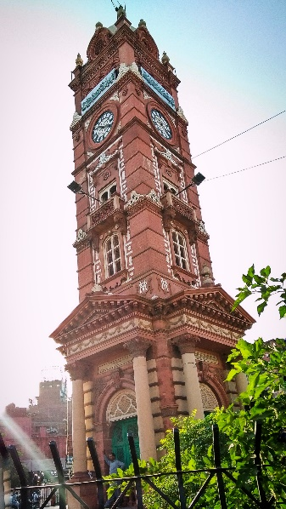.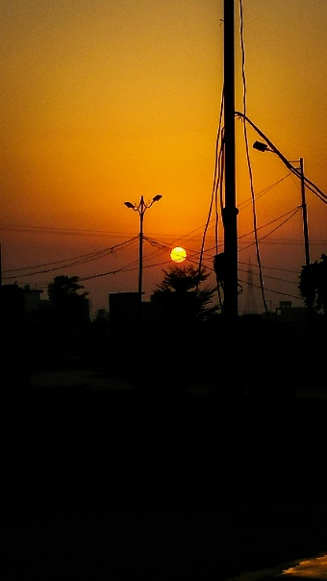.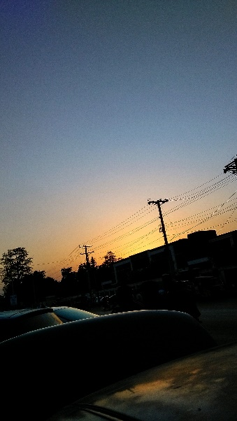.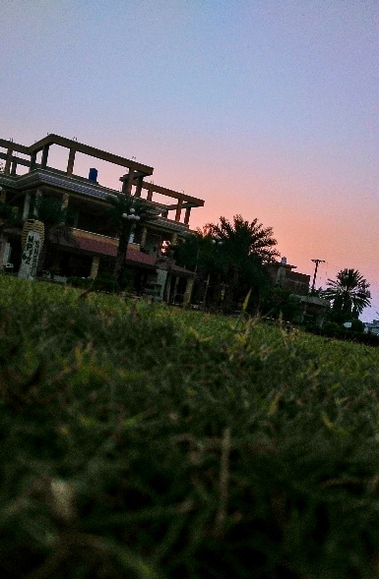

Sources:

<https://en.wikipedia.org/wiki/Faisalabad>

<https://www.britannica.com/place/Faisalabad>

<https://www.pakistangulfeconomist.com/faisalabad/>

<https://faisalabad.punjab.gov.pk/district_profile/>

Pictures:

<https://instagram.com/visions.by.abdullah_>

<https://maps.app.goo.gl/po6gwA2CNAfMFQgy5>